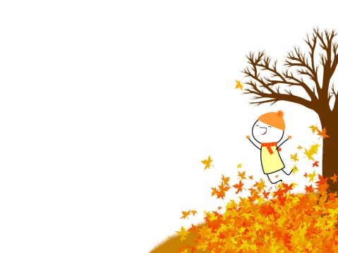
Writing Challenge - September

Instructions: After responding to any of the ideas on this page with a decorated ½-page or full-page in your Interactive Notebook, color in the completed box with a highlighter. When you create any “Five-in-a-Row”, “Four Corners,” or a complete “Blackout” Bingo, come and show your teacher to receive a special sticker for your work! You must complete five (5) of these activities before the challenge due date.

Create a half- or full-page tribute to your favorite food. Use words and pictures! | “Convince Me!” Prompt Think of a school rule you don’t like. Write a persuasive argument. | Unusual Nightmares Prompt! Describe and illustrate a bad dream that any invertebrate may have. | Attach a picture taken this past summer to a notebook page. Write about it with details! | What two numbers feud the most? Answer this question creatively in your notebook.
Create a three-panel comic strip that shows a student who doesn’t know how to study. | What does a cloud think about? Answer this question creatively in your notebook. | Make a list of good advice for a (real or imaginary) younger brother or sister. | Launch a list or a creative description that captures your idea of a “perfect day.” | You’re on a deserted island. You’re allowed three books and three songs. Which ones and why?
Personify an Abstract Noun! Choose a day of the week and turn it into a “person.” | Celebrate one of your favorite words by turning it into an acrostic poem. | Things I Treasure | Describe a room in your home from a unique point of view—like an insect’s. | Look at your ABC’s of Things You Might Write This Year list. Begin one in your notebook!
Create a three-column (nouns, adjs., verbs) word bank on this topic: School Words | Fake apology! Think of something bad you’ve done in the last week, and write an apology that sounds convincing. | Create an advertisement to sell one of your favorite articles of clothing. | “I was totally terrified!” Write a short narrative where this is your first sentence. Illustrate it! | Think of a family expression or inside joke and explain it using details and illustrations.
Make a list of six writing topics you think your fellow classmates would like to write to. | Write about a true or fictional embarrassing moment. Provide an illustration! | Start a page where you can record your favorite clean jokes. Write 2 or 3 down. Record more on this page as the year progresses. | Weird e-mail correspondence!  If a pet could e-mail its owner, what would the e-mail say? Write it! | Worst or best? Put one of these two adjectives in front of the word friend and write about what comes to mind.
Your completed challenge is due Wednesday, September, 30th.

